Week 4

**Perceptron**

Perceptron is a linear classifier.

Predicted Output = sgn function (dot product (Weight transpose and input) + bias)

Train weight vector and bias term

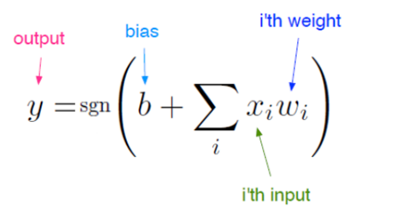

**Single Layer Neural Network**

**Chain Rule and Gradient Descent for Neural Network**

Single Layer Neural Network can’t handle non linear data, hence we add multiple neurons.

**Feed Forward Neural Network**

It is acyclic.

MLP Main Equation

Activation Functions



